The Enlightenment
Answer the following questions once the notes are complete.
  - What was it?
  - What were it’s characteristics?
  - What changes did it create?
  - How does it affect you?
- Enlightenment thinkers believed in
  - Natural Law
    - _____________________________________________________
  - Natural Rights
- Social Contract
  - At first, people lived in anarchy.
  - Anarchy was a little dangerous and violent.
  - To avoid these pitfalls, people choose a ruler.
  - The people and ruler agreed to an unwritten Social Contract.
- Social Contract- ________________________________________________________________________________________________________________________
- Philosophes
  - Term for the __________________________________________
  - Most of our Enlightenment Hall of Fame consists of philosophes
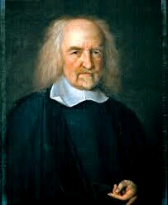
- Thomas hobbes
  - Philosophe/Author
  - __________________________________________
  - Didn’t like the chaos and violence it created
  - People must give up __________________in order to promote orderly society
  - ________________________________________________________. Everything else is given up to ruler.
  - Favored a strong monarch (absolute monarch) to maintain order.
    - Remember, he didn’t like the English Civil War
  - Believed people act out of their own self-interest, with little regard for others.
  - Only the strong survive, so the ____________________________________________ is needed to maintain order.
- John locke
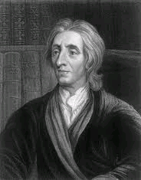
  - Philosophe/Author
  - Also lived through English Civil War
  - Believed no ruler should have _______________________
  - It goes against the laws of nature for one creature to rule over another
  - Accepted the Social Contract but…
    - People only gave up some of their rights and freedoms
  - _______________________________________________
  - Government should protect people’s rights
  - Believed we maintained three natural rights
    - _________
    - _________
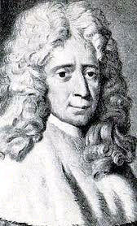
    - _________
- Baron de Montesquieu
  - French philosophe/author
  - Believed it is dangerous for all governmental power to be held by one person/branch
  - Separation of Powers
- The best form of government has powers divided among legislative, executive and judicial branches
- Separation of powers creates…
  - ______________________________________
    - U.S. example: Congress can pass a law but the president can veto that law and the Supreme Court can declare that law unconstitutional
- Jean Jacques Rousseau
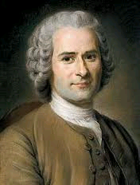
  - _______________________________________________________________________
  - People want to choose their government
  - Called for popular sovereignty – ________________________ ____________________________________________________
    - Direct Democracy
  - Opposed any monarchy
- Voltaire
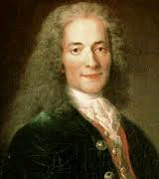
  - French writer
  - _______________________________________________
  - Imprisoned twice for criticisms
  - People should have the right to ______________________ ____________________________________
  - “I may disagree with what you say but I will defend to the death your right to say it.”
  - Also believed, people should have freedom of religion and practice religious toleration
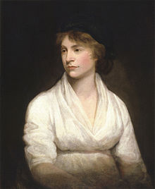
- MARY WOLLSTONECRAFT
  - Argued for the equality of _______________ with men
  - Women should have the ____________________ ______________________________________ as men
  - Women should have the same political rights as men
    - Suffrage – _____________________________

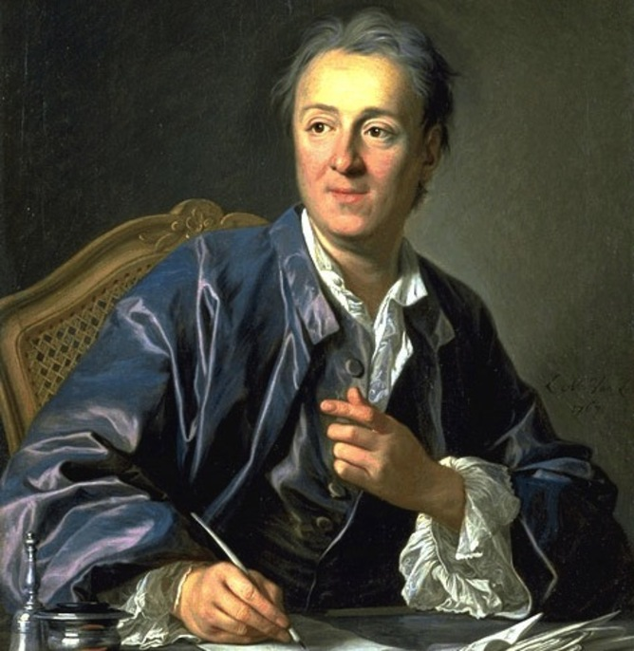
- Diderot
  - Created the __________________________
    - Classified Dictionary of the Sciences, Arts & Trades
  - 28 volume collection of knowledge
  - Attacked ___________________________________
  - Supported religious toleration
  - Sold to upper class, it spread_____________________________________

