World Studies I Tic-Tac-Toe
Over the next week, we will be showcasing our knowledge of World Studies I. You will have the opportunity to do this in a variety of ways, which you will choose. However, you need to choose in a tic-tac-toe fashion, meaning you can choose three in a row, three in a column or three diagonally.
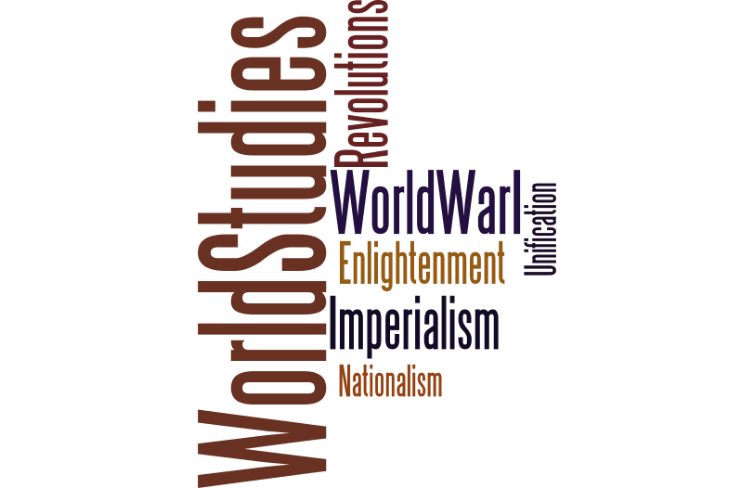
The main concepts that we have looked at throughout the semester are fair game for you to explore more in depth.
We all are aware that tests and quizzes are not always the best way to show what you know. With this culminating project, you will have the opportunity to present information in a way that you choose. So choose wisely!
By the end of this project you will:
- Be able to demonstrate your knowledge of World Studies
- Be able to make connections from then to today
- Have three products of your choice (tic-tac-toe)
- Have at least three sources for the project (MLA or APA format)
On the next page, you will find the choices from which to choose.
- Remember you must choose in a line.
On the third page, you will find a rubric to help guide your creations.
And on the final page, you will find your daily log sheet. You must have your sheet initialed each day. You will receive two initials on Mon., Dec. 14th (1 for weekend work, 1 for the day).
You should have fun with this project. Make sure you choose your direction carefully. As always, if you have questions, be sure to ask. Have fun and good luck!
Assignment Due: Wednesday, Dec. 16th
Directions: Select three project options to complete. You may select three across, three down or three through the middle.
Photo-essay/Art  Find pictures (or create your own) of working conditions during one of the eras and photos from our current time. Put them together in a collage using multimedia. Examples might be a PowerPoint, an online photo album on a site like Snapfish, a website, scrapbook, etc. Minimum of 15 pictures. Include captions with your pictures to provide a description of the images in 2-4 sentences per picture. | Research/Writing  Research current laws in the US. Find out what the laws are and then consider: How have the changes in the law affected the lives of the people? What caused the change? Do you think that there should be more legislation enacted to deal with the issue further? Write a letter to a policy maker or editor expressing your opinions, based on your research. | Musical  Create a soundtrack of at least ten songs that illustrates the essence (the working, living and social conditions) of the era. Songs might also explore how those conditions have changed over time. Themes you might include are sickness, stress, low pay, social class, etc. Design the cover of the CD as well as an explanation of why you selected those songs.
Drama  Write and produce a movie based on the life of someone living during one of the periods that we examined. The person can be a leader or someone from the lower ranks. You can act out the movie or use software to produce it. | FREE SPACE  For this section, you will choose the topic that you want to investigate further and choose the product that you will create to show your learning.  Some ways that you could do this are: creating a website, a children’s book, video essay, etc.  Once you decide on what you would like to do, you must have it approved by me. | Logical/Sequential  Create a series of charts that show rapid changes that occurred during a time period. For example, rights granted to people during the Enlightenment or changes of growth during the Industrial Revolution.  Ex: Manchester & London (England), Lowell, Massachusetts  Create the same series of charts that show rapid urban growth for modern times. Ex: China, India, etc.
Science/Health  Each era that we examined has had its own challenges concerning healthcare.  Poor and crowded living conditions, trench warfare, etc., led to the spread of many illnesses and diseases. Research the causes, symptoms, and treatments of one of these sicknesses. Then, create a public service campaign to educate the masses about the illness. This can include posters, brochures, commercials, etc. | Creative Writing  Imagine that you are living throughout the course of one of the eras. Write a series of diary entries (at least five) in the role of your assumed character. Be sure to record the events of your day and include specific details about your life. You should include not only activities and observations, but also your feelings and emotions during that time. | Technical  Research technology from one of the eras that we looked at and discuss the ramifications of its use. How did it affect the world back then? How does it affect us today?  How has the technology used then evolved into technology used today? Create a Wikipedia entry detailing how the technology was first introduced, how it was used during this era and how it evolved throughout the years.

World Studies I Tic-Tac-Toe Project Rubric
Work Ethic Rubric
Criteria | Emerging | Acceptable | Exceptional
Time on Task | Little time was spent on task during class. | Most of time was spent on task during class. | Nearly all of time was spent on task during class.
Daily Progress Checked | Student has >50% progress checks. | Student has majority of progress checks. | Student has all progress checks.
Student Planning | Student had plan but did not use it. | Student had plan and used it some. | Student had plan and used it often.
 |  |  | Score:
Students will receive 10 points based upon their daily planning and work.
Project Rubric
Criteria | Emerging (0-4 pts) | Acceptable (5-8 pts) | Exceptional (9-10pts) | Score
Content Knowledge | Student has some understanding of World Studies content | Student understands most of the World Studies content | Student has clear understanding of World Studies content
Focus and Organization | Project has little focus and is not easy to follow | Project has some focus but is not easy to follow | Project has clear focus and flows easily
Presentation of material (x3) | Student has presented material though it is not particularly neat and would not attract an audience | Student has presented material in a fairly neat way that may attract an audience | Student has presented material in a neat, engaging way that attracts an audience
Completion of Task  (x3) | Student has completed some of the work required in the boxes chosen | Student has completed most of the work required in the boxes chosen | Student has completed all of the work required in the boxes chosen.
Use of evidence | Student has zero or one sources. | Student has at least 2 sources. | Student has at least 3 sources.
Comments:

Project Total _________/ 100
Project Planning and Daily Progress Log
Project Planning: What line have you chosen? What topics have you chosen? And,why?

What will you be doing to present the information?

Daily Progress Log: Use the boxes below to plan out how you will complete the project
Day | Task Goal (Ind/Group) | Task Completed  (Ind/Group) | Initials
Wednesday
Dec. 9th
Thursday
Dec. 10th

Friday and Weekend
Dec. 11th
Monday
Dec. 14th
Tuesday
Dec. 15th

Due: Wednesday, Dec. 16th

