New Weapons

Central Powers

1__________________

2__________________

3__________________

4__________________

**Four Main Causes of WWI**

1

2

3

4

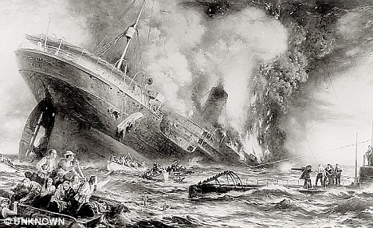[](http://www.google.com/imgres?q=black+hand+cartoon&um=1&hl=en&safe=active&tbo=d&biw=1600&bih=732&tbm=isch&tbnid=aYK1PiVLqVBRpM:&imgrefurl=http://www.redbubble.com/people/albertism/works/8260734-black-hand-cartoon?p=sticker&docid=N7hWFrsyJrf9KM&itg=1&imgurl=http://ih3.redbubble.net/image.11202990.0734/sticker,375x360.png&w=375&h=360&ei=qs23UPOCF4O9yQGtpYCQBQ&zoom=1&iact=hc&vpx=1191&vpy=313&dur=3902&hovh=220&hovw=229&tx=119&ty=133&sig=115036327191400673110&page=2&tbnh=142&tbnw=150&start=40&ndsp=50&ved=1t:429,r:68,s:0,i:291)[](http://www.google.com/imgres?q=Gavrilo+Princip+cartoon&um=1&hl=en&safe=active&tbo=d&biw=1600&bih=732&tbm=isch&tbnid=QGM6mOVT9bBrGM:&imgrefurl=http://www.salamunicblog.com/2010/05/spark-concept-illustrations-for-gavrilo.html&docid=xROHpI7xvidzYM&imgurl=http://2.bp.blogspot.com/_Z80jR9WIcmA/S_rJDW804zI/AAAAAAAAFFo/nXY52MvpkdI/s1600/illo85b.jpg&w=798&h=1000&ei=Z8u3UP30GoGMyQH3voHwBA&zoom=1&iact=hc&vpx=865&vpy=122&dur=7091&hovh=251&hovw=200&tx=108&ty=109&sig=115036327191400673110&page=1&tbnh=140&tbnw=115&start=0&ndsp=44&ved=1t:429,r:6,s:0,i:101)

# of Soldiers Killed

-------------

Armistice: Time:

____/_____/_____

**Winner**

**Loser**

Triple Entente

1_____________________________

2_____________________________

3_____________________________

Triple Alliance

1_____________________________

2_____________________________

3_____________________________

Allied Powers (6 major)

1__________________

2__________________

3__________________

4__________________

5__________________

6__________________