WWI Web quest Name: ________________________________________________
Type in the following link into the browser: http://www.pbs.org/greatwar/
Click on the “Prologue” box to take you to the Introduction to the Great War. Read this page and answer the following question.
- What made this war unlike any other war previously fought?

Click on the “Explosion Stalemate page (purple box). Read this page and answer the following questions. (Make sure to click on the links that say “more on Stalemate” )
- Describe what the “Schlieffen Plan” was.

- What caused the war to grow rapidly out of hand?

- Once the German advance was halted, what actions were taken causing a stalemate?

Click on the link that says “@trench Warfare”

- How many estimated miles were dug by both sides towards the end of 1914?

- What happened to bodies that were caught in between trenches?
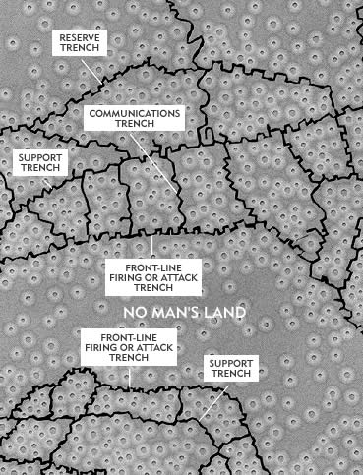
- What are the four different types of trenches talked about on this page? Describe each one.

- What is “No man’s Land”?

- During trench warfare, when was most the fighting taking place and why?

Click on “Total War / slaughter” page. (green box) be sure to click on the “more on total war” link too
- How did the war affect the lives of civilians? Describe what happened.

- Describe the first Genocide of the 20th century.

Click on the “slaughter” link
- What happened at The Battle of Verdun?
Click on the “Mutiny/ collapse” page. (blue box) be sure to click on the “more on mutiny” and “more on Collapse” buttons too.
- Why did mutinies take place during the war?

- What happened to Russia towards the end of WWI?

Click on “collapse”
- What country was approached by Germany?
- What country helped force the Germans to finally surrender?
Click on “Hatred & Hunger/War without End” page. Read “War without End” and respond to the writing prompt.
- What was the German’s mentality after WWI was finished?

